Site Evaluation Guide

What is a Site Evaluation?
A site evaluation is an investigation of a property to determine if it is capable of adequately treating wastewater in order to prevent risk to public health and reduce the degradation of water quality and the environment.

Factors used to determine site suitability:

► useable area for initial and ► slope replacement absorption areas ► encumbrances
► soil profile ► unstable land forms
► distance and separation to ► possibility of
water tables connecting to sewer
► parcel size

► setbacks to:
- wells
- cuts and fills
- surface bodies of water
- escarpments or rock outcroppings

If an Environmental Health Specialist (EHS) determines the site is suitable for an onsite wastewater treatment system, the EHS will identify the approved location and type of onsite wastewater system allowed for both the initial and replacement dispersal areas. If there is insufficient useable area or not enough effective soil to support a standard drainfield there are alternative onsite systems that can function with less area and less effective soil depth. The onsite evaluation rules require all system types be considered before denying a property for any onsite wastewater treatment system.

When is a Site Evaluation

Required?

A site evaluation is required before any onsite

wastewater or building permits can be issued for

existing lots, or when partitioning or creating new lots. The first step to approval for a new onsite wastewater treatment system is the site evaluation.

If a valid site evaluation exists within County records, a new evaluation is not required. However, if: (1) a site evaluation on record has incomplete information, (2) the property has been altered or partitioned, or (3) new information has been discovered, a re-evaluation may be required. If you wish to place your drainfield in an area different from the "Approved Area" identified on the existing site evaluation, a new site evaluation will be required.

In addition, site evaluations completed before January 1,1974 are no longer valid. Site evaluations completed after January 1,1974 are valid (pending the above said), but additional fees may apply if additional site work is needed (see fee schedule).

I - - -

- - - - - -- -

How do I get started?
An applicant must prepare a minimum of (2) test pits dug into the soil profile (See Test Pit Requirements on page 3 for more details), and the property corners need to be located and staked or flagged.

Once test pits are prepared, an applicant may request a site evaluation by obtaining and completing a Site Evaluation Application form. A complete application must include an accurate sketch of the property identifying roads, other landmarks, and the location of the test pits in reference to the closest two property lines.

It is critical that water wells are identified and distances accurately noted, including wells on adjacent properties.

Large properties may be sketched on a separate sheet of paper but the application form must be signed and submitted along with the sketch.

When necessary, provide a vicinity map identifying the property along with clear written driving directions. An orange address card should be visibly posted near the property entry point, which is provided by the county when the application is submitted. Incomplete and/or incorrect information may delay the completion of the site evaluation.

When will the results be available and what do they mean?
After the site evaluation is submitted, Lincoln County attempts to complete all site evaluations within 30 days; however, Oregon Administrative Rule does not require site evaluations to be completed in a specific timeframe.

During the winter, site evaluations may be postponed due to weather and soil conditions. A site evaluation cannot be performed if the ground is frozen, snow covered, or the test pits filled with water. If weather or soil conditions impact the timeline of a site evaluation, the applicant or authorized representative will be contacted.

Upon completion of the site visit, a County Environmental Health Specialist will complete a site evaluation report that states the status of the application. If the application is approved, the report also specifies the approved location for the dispersal area, the type and size of onsite system components required, and any special items required for installation of the system . If the site is denied, the report will provide the reasons for denial. The site evaluation letter is mailed as soon as it is ready.

How long is a site evaluation valid?
Lincoln County is confident of all site evaluations less than 15 years old. However, the County must consider the completeness of the existing site evaluation, and if new Department of Environmental Quality (DEQ) rules apply or new information changes the property's suitability for an onsite wastewater system. Lincoln County will make every effort to permit an onsite wastewater system on a previously approved lot, but will not jeopardize public health in that effort.

Test Pit Requriements

Providing Access to the Standard Test Pits
Overview
For easy access, one end of the test pit shall be either:

To properly evaluate a site's ability to treat and disperse wastewater, an Environmental Health Specialist must study the soil profile of the property. This examination is conducted standing in holes excavated into the ground, known as test pits.
I Sloping Entrance

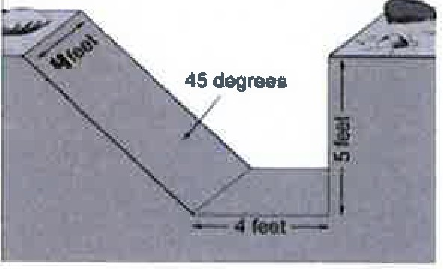
Sloped at approximately 45 degrees or less if the soils are dry or loose

All spoils need to be a minimum of 2 feet from the pit edge.

8tappad Entrance

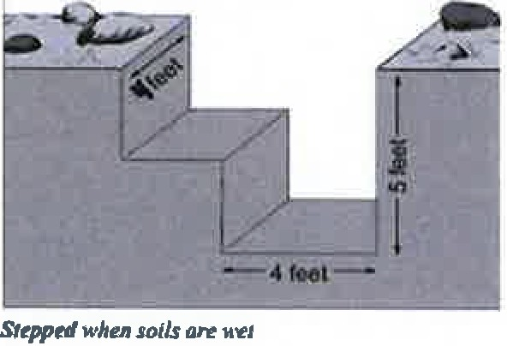

How to prepare test pits
- The applicant should provide a minimum of (2) test pits.
- The test pits should be approximately (60-75) feet apart and located in the area most likely to be used for wastewater dispersal. If the proposed replacement area is located in a different area of the property, at least (2) additional test pits should be dug in that space.
- The test pits should be (4) feet long by (4) feet wide and (5) feet deep to allow an individual to enter the pit and examine the pit walls. One end of the pit must be sloped or stepped to allow safe access in and out of the pit (to prevent entrapment of children or animals). If it is not possible to dig to a depth of (5) feet, then dig the hole as deep as possible. A licensed Department of Environmental Quality (DEQ) installer is recommended to dig the test pits.


Department of Planning & Development
210 S. W. 2nd Street.
Newport, OR 97365
(541) 265-4192
(541)-265-6945 Fax LConsite@co.lincoln.or.us

