ARGUMENT STATEMENT FOR COUNTY VOTERS’ PAMPHLET

Ballot Title Caption:

Measure Number: Word Total (325 Maximum):
☐ Argument in Favor ☐ Argument in Opposition

Person responsible for the content of the ARGUMENT STATEMENT:

(Typed)

(Signed)
Name of the Organization person represents, if any:

EXPLANATORY STATEMENT FOR COUNTY VOTERS’ PAMPHLET
Ballot Title Caption:

Measure Number: Word Total (500 Maximum):

Person responsible for the content of the EXPLANATORY STATEMENT:
[Grab your reader’s attention with a great quote from the document or use this space to emphasize a key point. To place this text box anywhere on the page, just drag it.]
(Typed)

(Signed)

Name of the Organization person represents, if any:

STATEMENT OF ENDORSEMENT

I, consent to the
(Printed Name of Individual or Organization Being Used)
use of my name or the name of the organization I am authorized to represent in the Lincoln County Voters’ Pamphlet statement submitted by the following:

(Printed Name of Candidate or Ballot Measure Statement Using Endorsement)

In Support Of ☐ In Opposition To ☐

Ballot Measure Number:

At the Election, 20

(Indicate Applicable Election)

Dated on this day of , 20

(Typed)

(Signed)
Name of the Organization person represents, if any:

*Oregon law specifies that a person shall not submit a false signature (ORS 251.405).

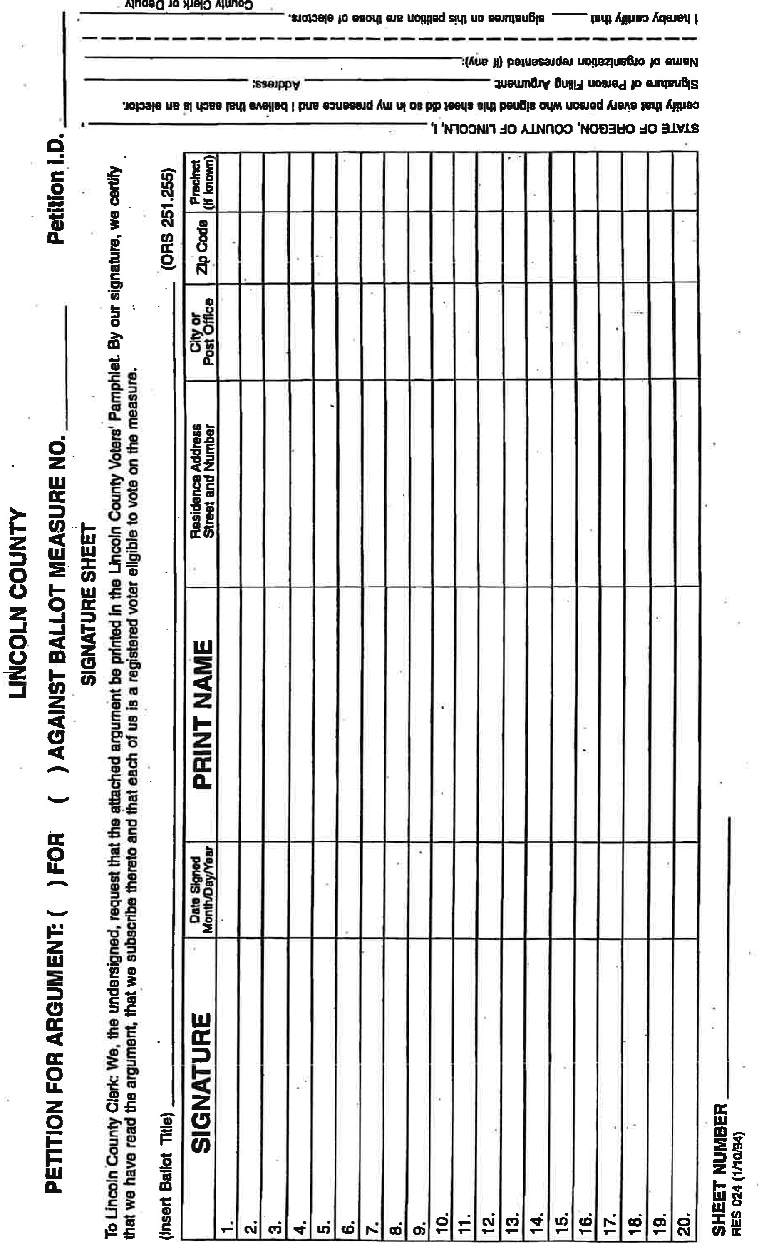
Ałndaa
10
Ńunoo

